Experiment no.2

Dart I/O & loops

1. Dart Input and Output

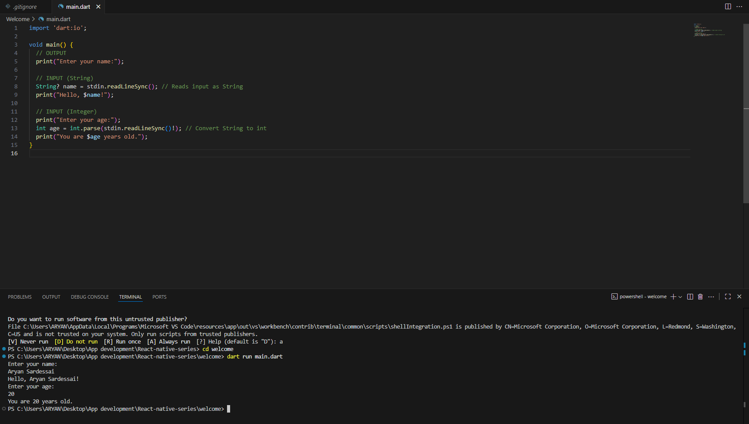

1. Dart loops

